**Experiment 2.2**

**Student Name:   Gaurav Kumar                                UID: 22MCC20177**

**Branch:   CC-DevOps                                                        Section/Group: 1/B**

**Semester:   I                                                               Date of Performance: 17/10/2022**

**Subject Name: ADBMS                     Subject Code: 22CAP-647**

1. **Task to be done:**

You are given two tables: *Students* and *Grades*. *Students* contains three columns *ID*, *Name* and *Marks*.

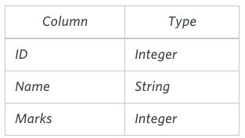

*Grades* contains the following data:

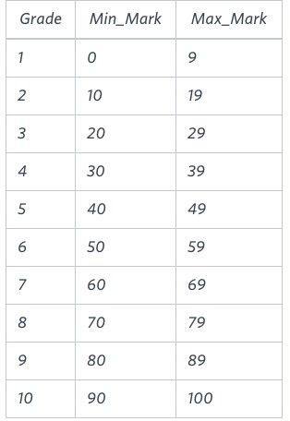

*Ketty* gives *Eve* a task to generate a report containing three columns: *Name*, *Grade* and *Mark*. *Ketty* doesn't want the NAMES of those students who received a grade lower than *8*. The report must be in descending order by grade -- i.e. higher grades are entered first. If there is more than one student with the same grade (8-10) assigned to them, order those particular students by their name alphabetically. Finally, if the grade is lower than 8, use "NULL" as their name and list them by their grades in descending order. If there is more than one student with the same grade (1-7) assigned to them, order those particular students by their marks in ascending order.

Write a query to help Eve.?

**Query :**

**mysql>** select IF(grade>7,Name,NULL) as Name,Grade,Marks from students, grades

**->** where marks between min_marks and max_marks

**->** order by grade desc, Name, marks;

+--------+-------+-------+

| Name | Grade | Marks |

+--------+-------+-------+

| Maria | 10 | 99 |

| Jane | 9 | 81 |

| Julia | 9 | 88 |

| Scaret | 8 | 78 |

| NULL | 7 | 63 |

| NULL | 7 | 68 |

+--------+-------+-------+

**6 rows in set (0.00 sec)**

1. **Learning outcomes (What I have learnt):** 
   * 1. **Learn about Aggregate function**
     2. **Learn about group by clause**
     3. **Learn about having clause with aggregate functions**

**Evaluation Grid:**

|  |  |  |  |
| --- | --- | --- | --- |
| Sr. No. | Parameters | Marks Obtained | Maximum Marks |
| 1. | Demonstration and Performance  (Quiz) |  | 22 |
| 2. | Worksheet |  | 8 |